**ftpijf;fhd khfhzkl;l cau; tpUJ**

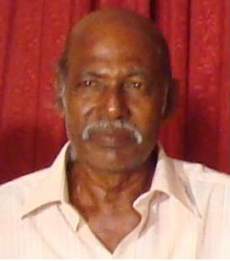

2010k; Mz;bw;fhd “ **fpof;F khfhz jkpo; ,yf;fpa tpoh “** tpy; ftpijf;fhd Kjyikr;ru; tpUjpw;fhf fhiujPT – 11k; gpupitr; Nru;e;j ftpQu; nghd;. rpthde;jd; mtu;fs; njupthfpAs;shu;.

Kjyikr;ru; tpUjpw;fhfj; njupTnra;ag;gl;l 15 fiyQu;fspy;> ,t; tpUjpw;fhf ,tu; gupe;Jiuf;fg;gl;Lssik Fwpg;gplj;jf;fJ. NkYk; vjpu;tUk; 2010 xf;Nlhgu; 23> 24k; jpfjpfspy; jpUNfhzkiyapy; eilngwtpUf;Fk; tpUJ toq;Fk; epfo;tpy; mtu; nfsutpf;fg;glTs;shu;.

kz;^iug; gpwg;gplkhff;nfhz;l Xa;Tngw;w mjpguhd ,tu; Vw;fdNt gpuNjr kw;Wk; khtl;l kl;lq;fspy; gy tpUJfisg; ngw;Ws;sikAk; ,q;F Fwpg;gplj;jf;fJ.

,tUf;F ,t;tpUJ fpilf;fg;ngw;wikiaapl;L fhiujPT kw;Wk; kz;^u; kf;fs; ngUkpjk; nfhs;fpd;wdu;.

**gj;jpupif thapyhf……. (tPuNfrup – 19.10.2010)**

