**fyhG+\z tpUJ – 2010**

**ftpQu;. nghd;. rpthde;jk**;

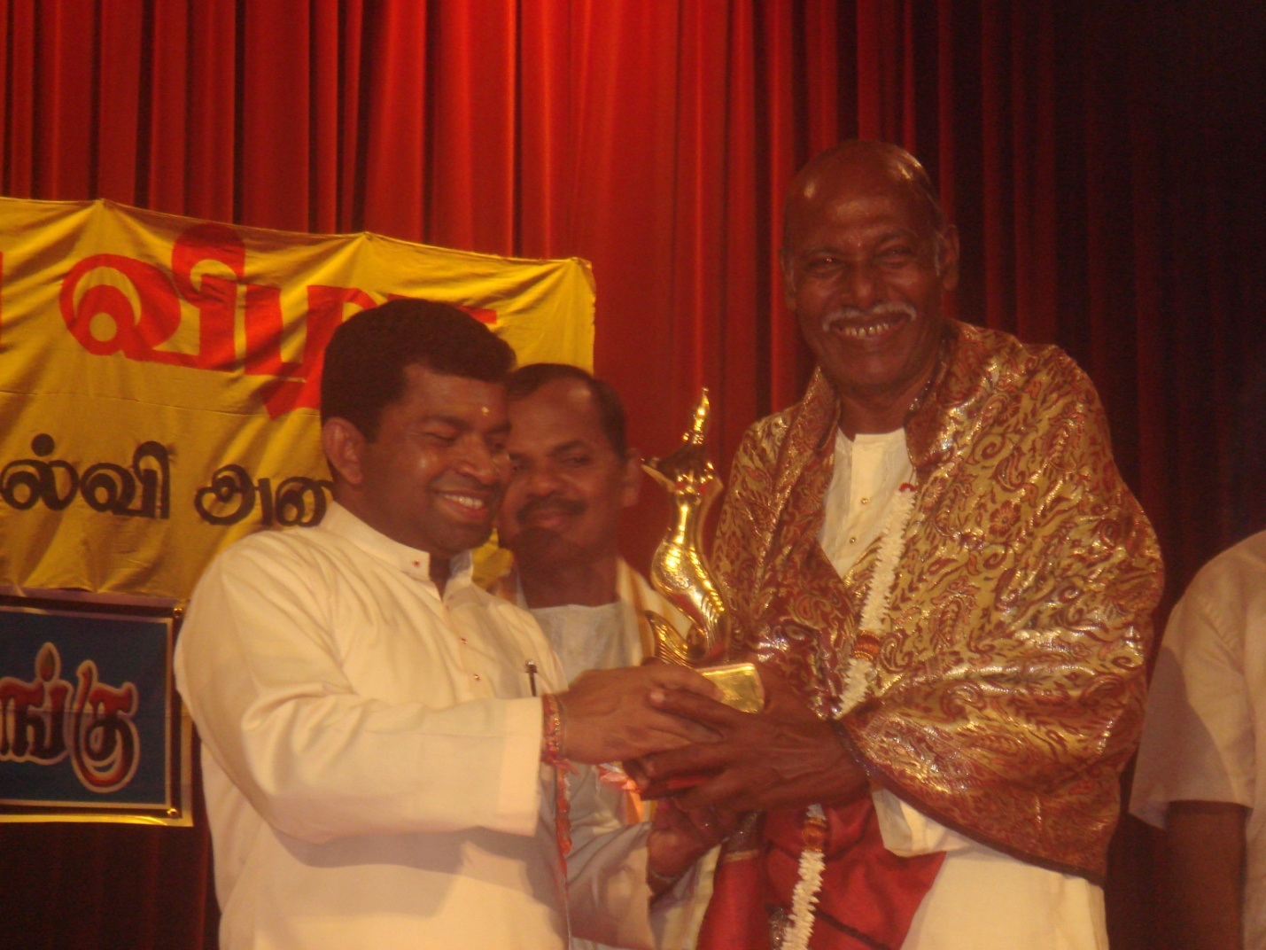

2010k; Mz;bw;fhd **“fyhG+rzk;”** tpUJ ngWgtu;fspy; xUtuhf ftpQu;. nghd;. rpthde;jk; mtu;fSk; njupTnra;ag;glLs;shu;. ,t;tpUjhdJ ,e;Jrka fyhrhu mYty;fs; jpizf;fsj;jpdhy; ,tUf;F toq;fg;gLfpdwJ.

Nkw;gb tpUJ toq;Fk; itgtkhdJ vjpu;tUk; **brk;gu; khjk; 15k; jpfjp N[hd; B rpy;th Qhgfhu;j;jf; fiyauq;F> nfhOk;G – 07** ,y; ,lk;ngwTs;sJ.

Vw;fdNt gy tpUJfisg; ngw;Ws;s ,tu; ,t;tUlk; fpof;F khfhzf; fyhrhuj; jpizf;fsj;jpdhy; **“khfhz Kjyikr;ru; tpUJ”** toq;fpf; nfsutpf;fg;gl;lhu; vd;gJ Fwpg;gplj;jf;fJ.

Xa;T ngw;w mjpgUk;> rpwe;j ftpahw;wy; kpf;ftUkhd ,tu;> kz;^u;> fhiujPTg; gpuNjrq;fspy; kl;Lky;yhJ khtl;l> khfhz kl;lq;fspYk; jd;idg; gpujpepjpj;Jtg;gLj;jp ,yf;fpa> rka> fyhrhu kw;Wk; r%f Nkk;ghLfSf;fhf mauhJ cioj;jtu;. ,tu; ngWk; mjpAau; tpUjhf ,t;tpUJ fpilg;gijapl;L fhiujPT kw;Wk; kz;^u; kf;fs; kpf;f kfpo;r;rpailtNjhL jq;fs; tho;j;Jf;fisAk; njuptpj;Jf;nfhs;fpd;wdu;.